Swamps, Rivers & Ranges Membership form

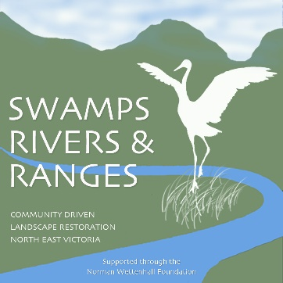
I . . wish to apply to become a member of Swamps, Rivers & Ranges and support its purpose:

“The purposes of the association are to strengthen the connections between landholders, land managers and land users in our local community to promote healthy people and landscapes connected to and supporting each other.
We will promote, strengthening and supporting our community’s natural resources and landscapes through respectful, nurturing and sustainable measures so that our environment may thrive.”

Membership is at a cost of $22 for a 3 year cycle to be counted from the start of each Calendar year.

I agree to comply with the Swamps, Rivers & Ranges Inc. Association rules and to pay the $22 membership fee.

Name:. .
Email:. .
Address: .
Phone:. . Date:. .
Membership fee payable by direct credit to:
Swamps, Rivers & Ranges Inc
Please contact for banking details
Reference: SRR member-your name

SRR use only:
Application received and processed:. .
Payment received:. .
Signed:. .

